Debug Javascript code to eliminate errors

*Code that have highlighted red fonts are fixed errors.*

**1)** Conditional statement incorrect – Fix the error in the conditions and add an extra { on line 101 to close the function.

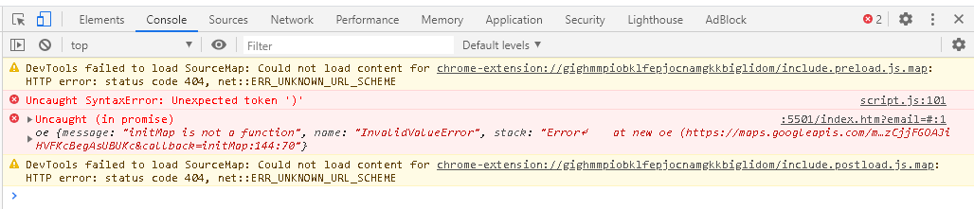

    submitHandler: function(form) {

        // do other things for a valid form

        $('.section2').removeClass('open')

        $('.section3').addClass('open')

        iPeople = parseInt($('#slct2').val())

        console.log(iPeople)

        if(iPeople==1 && 1<=iDays<=5){

            $('.choice-motorbike').addClass('available')

        }

        if(iPeople<=2 && 1<=iDays<=10){

            $('.choice-smallcar').addClass('available')

        }

        if(iPeople<=5 && 3<=iDays<=10){

            $('.choice-largecar').addClass('available')

        }

        if(2 <=iPeople<=6 && 2<=iDays<=15){

            $('.choice-motorhome').addClass('available')

        }

})

Conditional statement correction

        if(iPeople==1 && 1<=iDays && iDays<=5){

            $('.choice-motorbike').addClass('available')

        }

        if(iPeople<=2 && 1<=iDays && iDays<=10){

            $('.choice-smallcar').addClass('available')

        }

        if(iPeople<=5 && iDays>=3 && iDays<=10){

            $('.choice-largecar').addClass('available')

        }

        if(iPeople>=2 && iPeople<=6 && iDays>=2 && iDays<=15){

            $('.choice-motorhome').addClass('available')

        }

**2)** Originally, section 3 had an issue after you select your chosen vehicle. The next page appeared at the area where the customer pressed select. Adding in the scrollTop would eliminate proceeding to the wrong area of the next section.

$('.choice').on('click',function(){

    iPrice = parseInt($(this).data('price'))

    sChoice = $(this).data('choice')

    fFuelRate = parseFloat($(this).data('fuel'))

    iTotal = iDays * iPrice

    $('#inputSeconds').val(fFuelRate)

    $('.section3').removeClass('open')

    $('.section4').addClass('open')

    document.querySelector("#vehicleprice").innerHTML = iTotal

    $(document).scrollTop(0)

})

**3)** An error keeps appearing about the sourcemap unable to load. It is only an issue with browsers being unable to load a sourcemap that is not bundled with the axe extension and does not affect the functionality of the extension. This error doesn’t affect the functionality in any way so I decided to leave it.

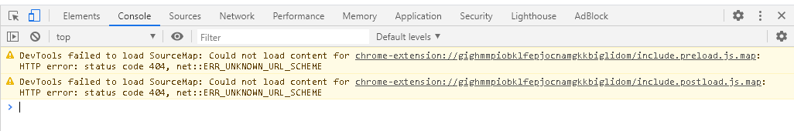

**4)** When customers want to rent the vehicle the booking day is the first day of the rent and day 1 is included for payments. In order for me to make the rent start from day one was to add in +1 for the var statements.

var lightpick = new Lightpick({

    field:document.querySelector('.my-days'),

    singleDate:false,

    numberOfMonths:1,

    minDate:moment(),

    maxDate:moment().add(14,'day'),

    onSelect: function(start,end){

        if(end != null){

            iDays = end.diff(start,'days') + 1

            document.querySelector('.days').innerHTML = iDays

        }

    }

})

**5)** For the fuel cost calculator, I have first used random variable names as a start. Later on, when I tried to change the variable to other names, it wouldn’t work. There was no way to fix this, so I decided to keep this because it didn’t affect the calculations for the fuel cost.

  //Fuel cost calculator

  function calculateFuelCost() {

    var feet = document.getElementById("inputFeet").value; //Distance

    var time = document.getElementById("inputSeconds").value; //L/100km

    var minutes = document.getElementById("inputMinutes").value; //Fuel price

    var mph = ((feet * time) / 100) * minutes; //the equation here

    document.getElementById("result").innerHTML = mph.toFixed(2);

  }

**6)** When selecting the North Island, all the distances are correct. However, there was no way I was able to check if the map could calculate the distance from the North to the South Island, so I used Google maps for this to check if the results were true.

$(function(){

    $('button').on('click',function(e){

        e.preventDefault()

        var sFrom = $('#from').val()

        var sTo = $('#to').val()

        var request = {

            origins: [sFrom + ' New Zealand'],

            destinations: [sTo  + ' New Zealand'],

            travelMode: google.maps.TravelMode.DRIVING,

            unitSystem: google.maps.UnitSystem.METRIC,

            durationInTraffic: true,

            avoidHighways: false,

            avoidTolls: false

        }

        distanceService.getDistanceMatrix(request,function (response, status) {

            if (status !== google.maps.DistanceMatrixStatus.OK) {

                console.log('Error:', status)

            } else {

                //console.log(response);

                $('h1>span').html(response.rows[0].elements[0].distance.value)

                $('.distance').html(response.rows[0].elements[0].distance.text)

                $('.time').html(response.rows[0].elements[0].duration_in_traffic.text)

            }

        })

    })

})

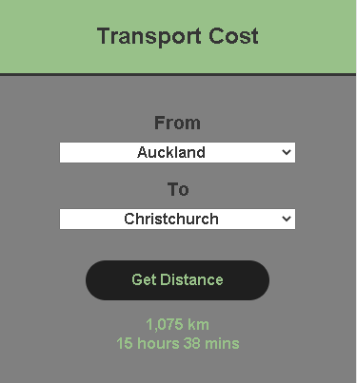 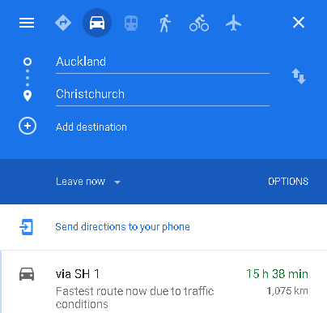

**7)** Checking if the input values came out correctly along with the calculations. Below is an example of showing the same values.

Number of people in vehicle **(iPeople = 3 people),** Number of days renting vehicle **( iDays=7 days),** Price of rent per day **(iPrice=$144),** Fuel rate for selected vehicle **(fFuelRate=9.7l/100km),** Total cost for vehicle rent excluding petrol costs **(iTotal=$1008).** All results came out correct.

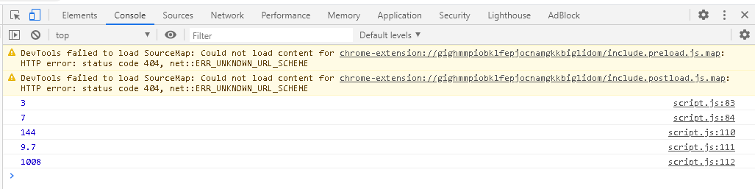

Extend a JS library with a 3rd party plugin

*Map to find out distance to calculate fuel cost

<script src="https://ajax.googleapis.com/ajax/libs/jquery/3.4.1/jquery.min.js"></script>

*To validate the input data - using data to sequentially proceed to next page

    <script src="http://ajax.aspnetcdn.com/ajax/jquery.validate/1.14.0/jquery.validate.js"></script>

*For general all Javascript use - functions, conditional statements, var statements

    <script src="https://cdnjs.cloudflare.com/ajax/libs/moment.js/2.22.2/moment.min.js"></script>

*Javascript & Css with specific styling for the calendar

    <script src="lightpick.js"></script>

*Connecting html with Javascript

    <script src="script.js"></script>

Use a range of production tools to assist in the development of a project

**Trello -** Planning of summative 2

**Figma** - For planning ideas of the website focusing on colour scheme, layout and information.

**Visual Studios** - Coding for html, css, javascript, jquery

**Google chrome (inspect)** - inspecting codes and seeing the component layout of the website.

**Photoshop** - For resizing the images to fit page content.

Quality assure own code by testing against industry standards (Use HTML validator to check)

*I have used this to check my html:* <https://www.freeformatter.com/html-validator.html>

The html validator has found 4 issues regarding nesting. An HTML document can contain multiple <form> elements, however, they cannot be nested within each other. Next time, I will focus on the form elements and nest them correctly. For the questionboxes2 class, I have closed the element but it turns out an error.

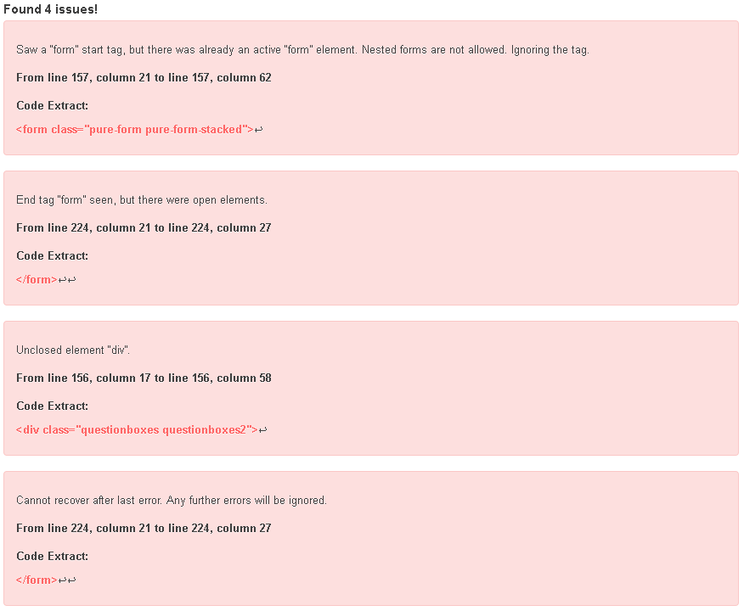

Define deliverables based on use cases prior to production

*File attached: Flow chart of mock-up plan*

*\* Weekends are not included from the timeline*

Throughout the project there were some changes I made to the format of the html. The sections were not clear to provide proper use of the Javascript. I first brainstormed a flowchart to re-plan how the one page website will work. I then proceeded with a solution that best works with Javascript. Due to the changes that I have made, I have started working on the Javascript one day after the original day I was supposed to have completed my html/css. For my next coming projects, I will plan my ideas more carefully towards how to work around Javascript rather than just focusing on the visual aspects.

Set critical deadline milestones for project during the planning stage, and analyse variations from this when signing off the project.

*For more details of the Summative 2 Timeline:* https://trello.com/b/qC4HNu7h